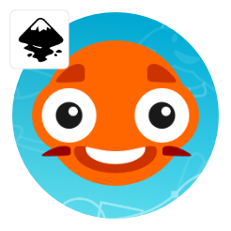
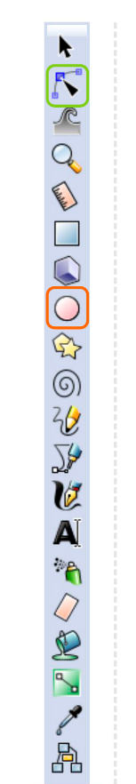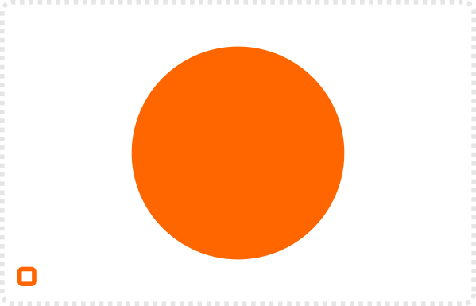
Start with a circle.
Add another smaller circle in the same colour and an even smaller white one. Create another circle and change the colour to black. Afterwards, add the fifth circle in white for the highlight.
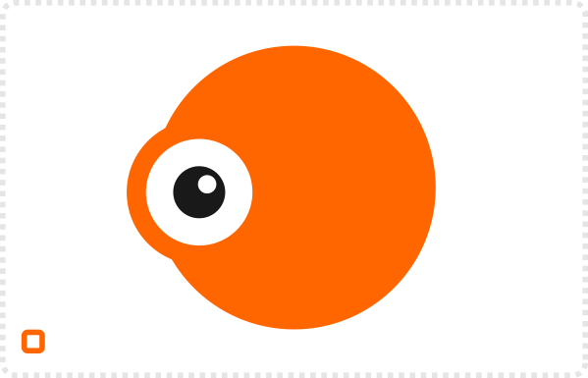
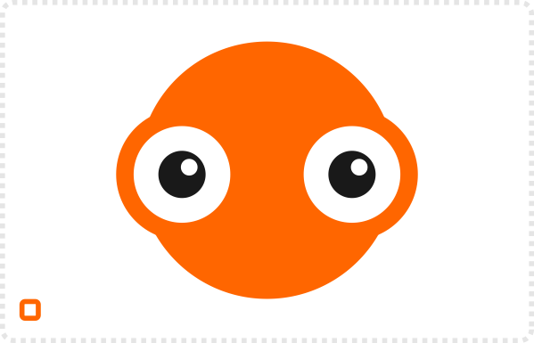
Duplicate [ CTRL + D ] the four ‘eye circles’ and move them over to the other side.
Add a small circle in a darker colour above the eye. Convert the circle to a path (Path/ Object to Path). The circle will now have 4 square markers for the nodes that ‘describe’ the vector shape. Use the Edit path tool to move the two nodes on the side and deform the shape.
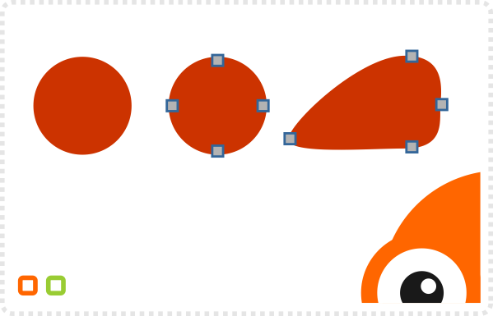
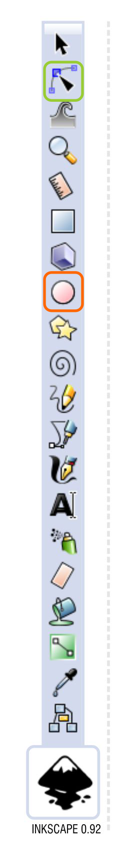
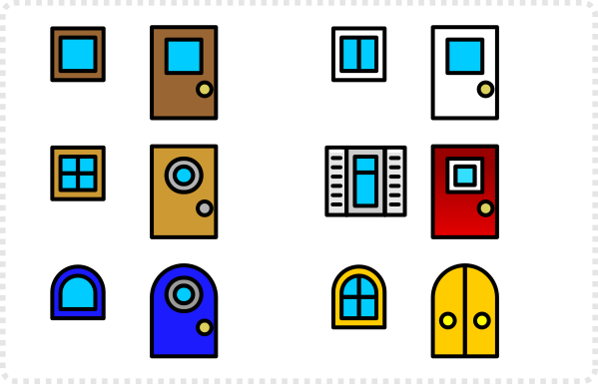
Add another darker circle and deform it’s side nodes to form a mouth.
Duplicate the mouth and change the fill to white. Adjust the nodes to match the shape of the mouth underneath.
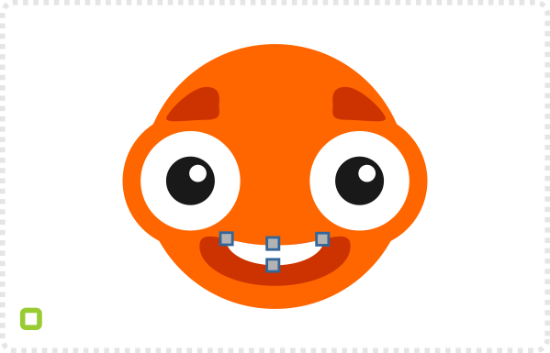
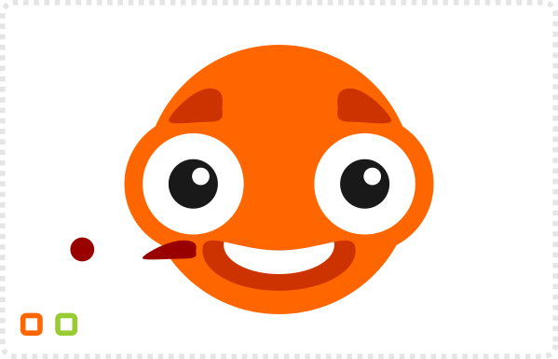
Create another small dark circle to add some detail to the face…
… and our simple game character based on circles is done.

Mirroring
Using the mirror tool (top menu bar ) makes it easy to flip elements like the eyebrows or whiskers. Make sure to keep the highlight in the eyes consistent though. A mirrored set of eyes looks odd when the highlights aren’t in the same place.
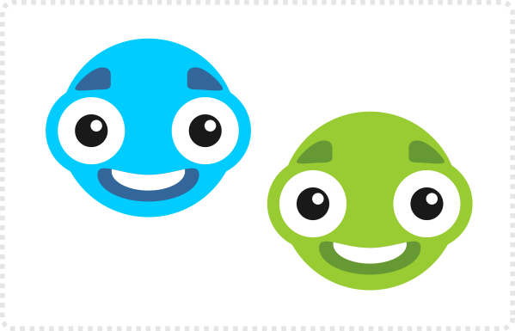
Recolouring the elements is quick and easy.
After changing the colours of the circles, scale the black and white circles. Moving their positions can give a whole new emotion to the character.
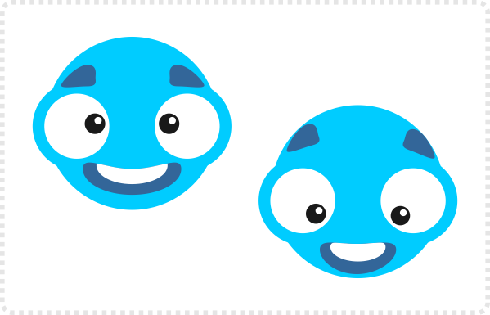
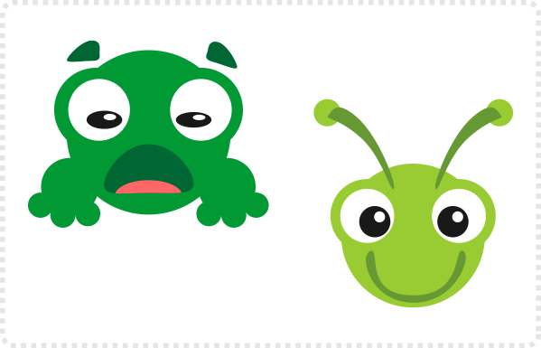
Duplicating and scaling the different elements allows for infinite possibilities. Distorting a circle to a mouth or antennas gives you totally new critters.
Altering the colours can change the character completely.
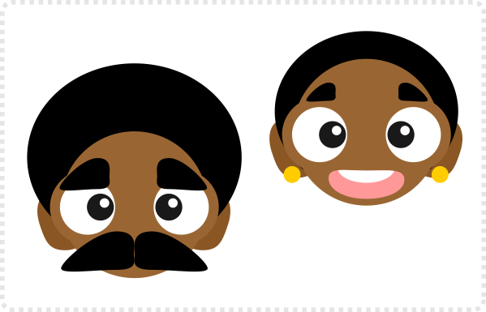
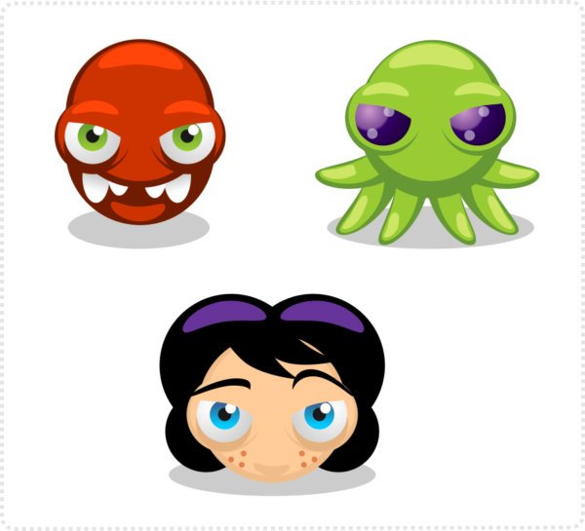
More advanced images can be created by using shading. This can be achieved with gradient fills or by adding lighter and darker versions of the base shapes. The latter option will resemble basic cell shading [more on that later].

