“Let’s create a circle” – well in this case we create three.
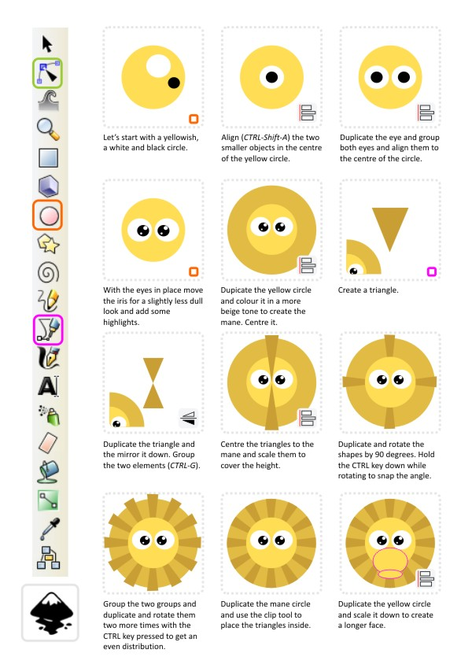
Note:
Users familiar with Adobe Illustrator or CorelDraw for example might ask why I bother with the duplication and rotation when it’s already build in. You create one copy, rotate it and the next copy will be a repeated version and you can create the full circle of triangles that way.
I find this way easier and more controlled when creating evenly spaced content for a circular shape.
Let’s give the lion some facial features. The mouth might like conplexe but really it’s just an up-side-down Y and if the deforming of the circle looks too difficult you might try using 3 separate elliptical shapes to create the same effect.
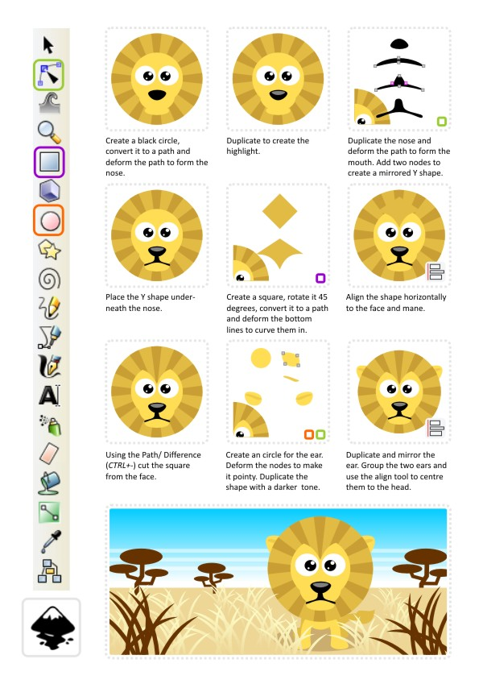

I added another circle for the body, a deformed circle for the leg and the paw, duplicated them 3 times to create the legs and added a line with a deformed circle with a pointy edge for the tail. A simple (and in my opinion cute) little lion.
With a little bit more detail (eyelids and eyebrows) it’s easy to give the lion some features and create some variations.
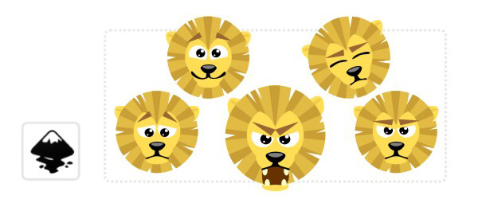
Variations don’t stop there. Taking the basic shapes, rearranging them and changing the colours you have a whole zoo at your fingertips.
