1. Draw the Body

Step 1
We're going to start with drawing some spikes. Grab the Polygon tool and select the Star polygon mode, then set Corners: 15 and Spoke ratio: 0.8. Then, just draw a polygon (size doesn't matter just yet) with a brown fill.
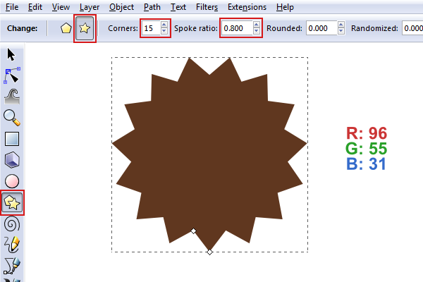

Step 2
Let's resize this polygon to W: 410px and H: 465px.
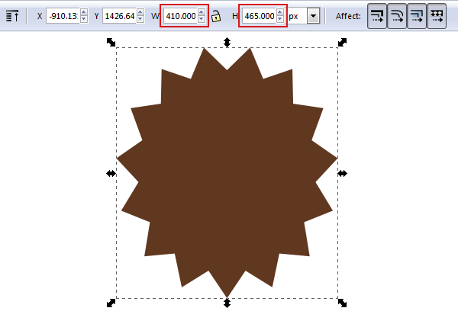

Step 3
For some added depth, let's duplicate the polygon and give the new one a fill slightly darker than the original. We'll be putting these shapes on top of each other later.
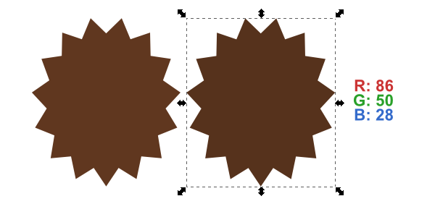

Step 4
Since we'll be overlapping these two shapes, let's give our new polygon a Stroke Width: 13px (same color as fill) so it stands out more.
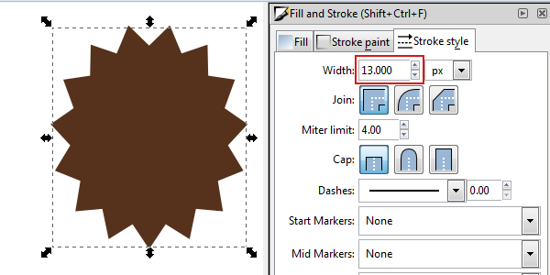

Step 5
With both of the polygons selected, pull up Object > Align and Distribute so we can get these situated. Click Center on vertical axis along with Align top edges. They should align as shown below.
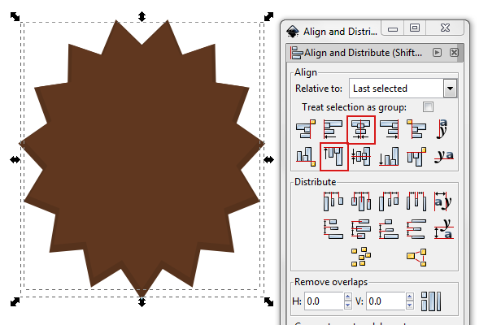

Step 6
Now we have to draw the inner-hedgehog body. Just grab the Ellipse tool and draw a perfect circle by holding Control-dragging. With this circle selected, head up to Path > Object to Path so we can manipulate this shape later. Also, give the fill a nice tan color.
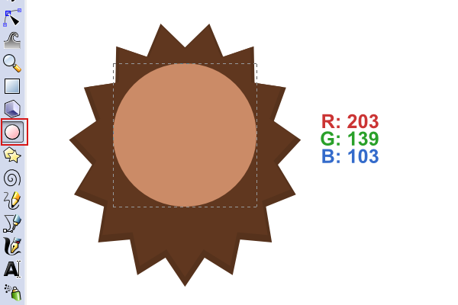

Step 7
We can now use the Nodes tool to transform this circle into a hedgehog shape as shown below. I ended up with a Height: 366px and Width: 266px.
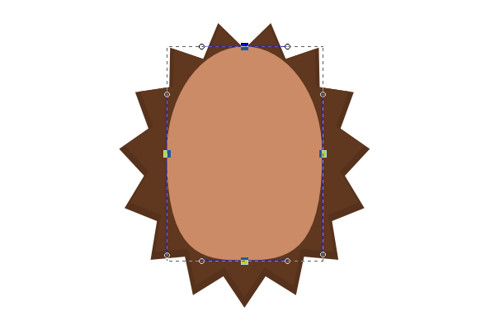

2. Draw His Eyes

Step 1
With the Polygon tool, draw a normal polygon with Corners: 3 so we get a perfect triangle. Hold Control to keep it straight. With the triangle selected, go to Path > Object to Path again.
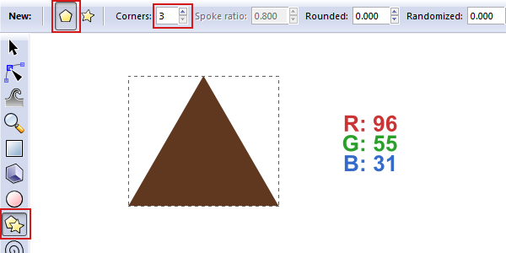

Step 2
Use the Nodes tool to select all of the nodes and then click Make selected nodes symmetric.
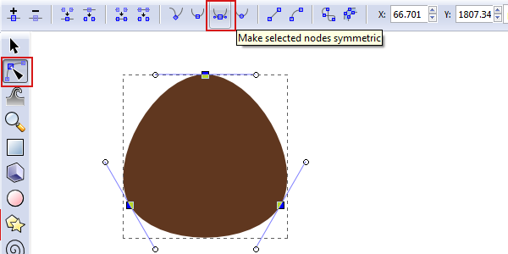

Step 3
This will be the dark spot under the actual eye balls, so use those nodes and handles to get a shape similar to below. You'll notice that I moved the eye spot onto the body at this point so I could get a better feel of what would look best.
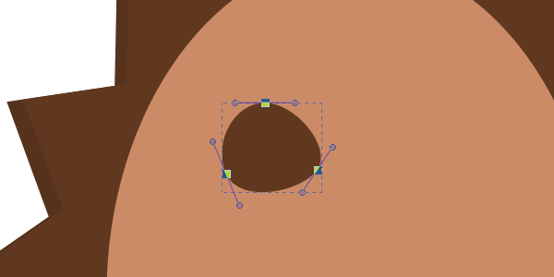

Step 4
For the actual eye ball, grab the Ellipse tool and hold Control-drag to create a perfect circle to fit in this eye spot. Give it a dark gray color.
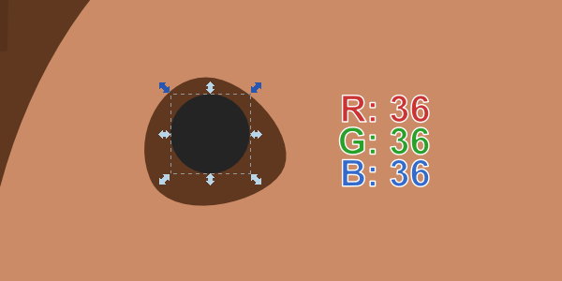

Step 5
Now do the same thing with even smaller circles to make some glare spots. You can just make these white.
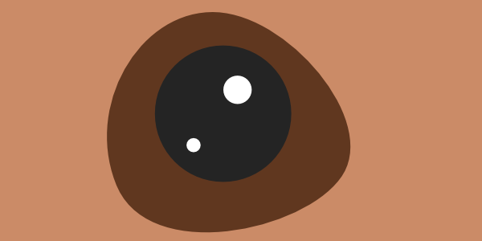

Step 6
When you're finished with one eye, you can duplicate it along with flipping it horizontally. Don't forget to skip flipping those glare spots!
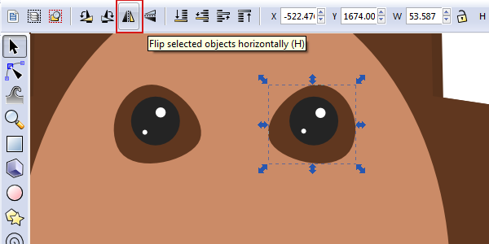

3. Draw the Snout

Step 1
As we've been doing, draw an Ellipse, Path > Object to Path, and manipulate nodes into a snout shape.
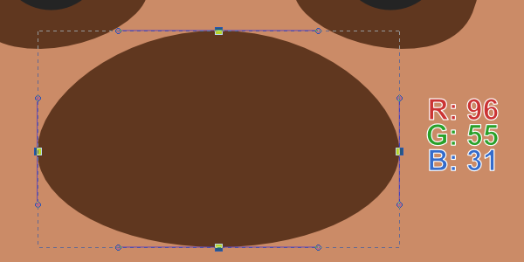

Step 2
Then we'll go ahead with a dark gray, oval shaped nose using the Ellipse tool. Also, we can just duplicate the nose and shrink it down for the glare spot (color of white, of course).
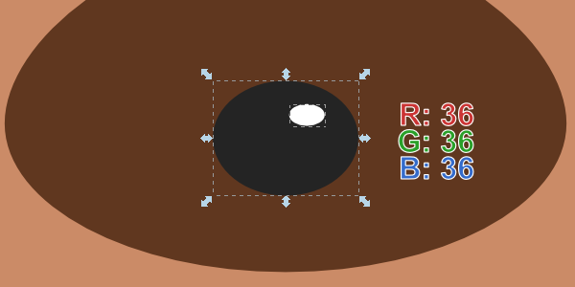
We should have something like this so far. You can always play with things such as eye spacing, nose spacing, etc. to ensure maximum cuteness.
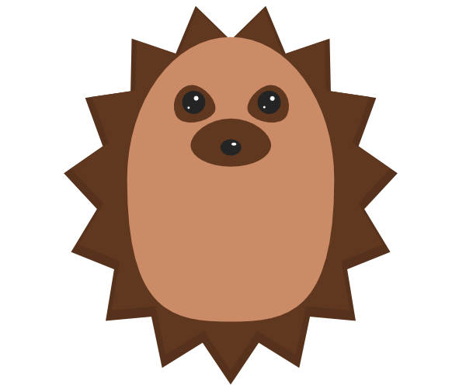

4. Draw the Ears

Step 1
To keep things simple, that brown eye spot we created can be duplicated for the ears - how convenient! I just rotated mine a bit to get the pointiest edge pointing outwards along with stretching it to a proper ear size.
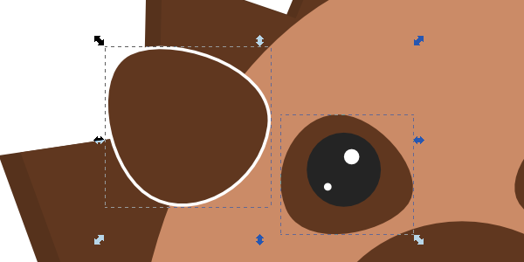

Step 2
Give this ear a nice thick Stroke width: 12px. Give the fill a pink/salmon color and make the stroke the same skin color. Also, send the ear behind the inner-body, but above the spikes. With the ear selected, you can use Page Up and Page Down to adjust this (or go to Object > Raise/Lower).
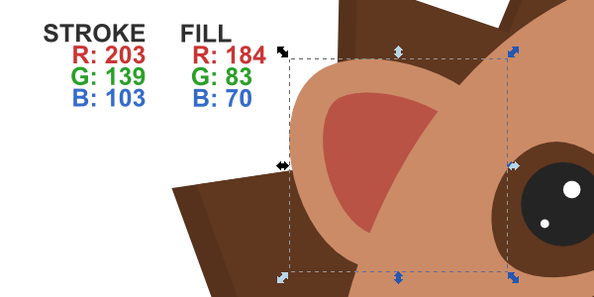

Step 3
And of course, duplicate and flip that ear for the other side. You can position these to your liking.
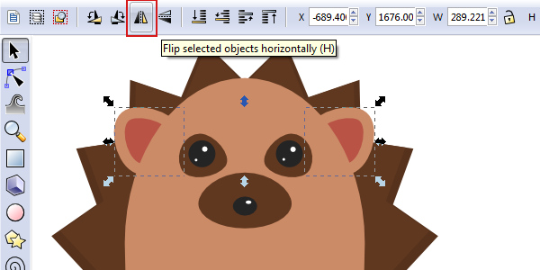

5. Use Tapered Lines for Hands and Feet

Step 1
The concept of doing custom strokes in Inkscape is to draw the shape you want for a path. For tapered lines in this case, I created a square, rotated it 45 degrees, and flattened it out as shown below. This way, our stroke will gradually come in and then gradually come out - tapered line.
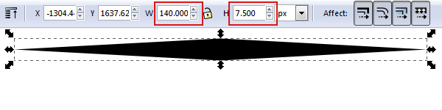
I've also smoothed the top and bottom nodes for extra slick strokes.
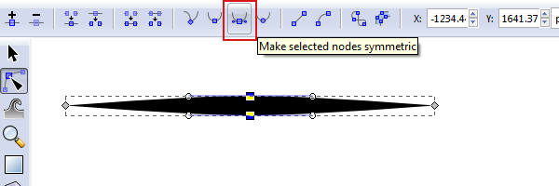

Step 2
For our tapered lines, we'll be using the Pencil tool. Set the Smoothing: 50 and Shape: From clipboard. From clipboard means whatever you've previously copied will be assigned as your stroke. So, select that tapered shape we made and copy it (Control + C). Then, go ahead and give it a test! I just drew a line to demonstrate below.
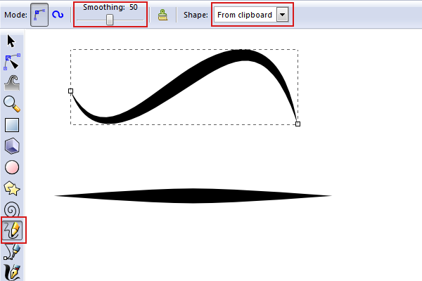

Step 3
With the Pencil tool still selected, go ahead and draw yourself a little hand-shaped thing. You can use the nodes afterwards to polish it up a bit. Now, when you go ahead and set the color to this, you'll notice it's actually a fill now instead of a stroke. I'll explain this issue later on.
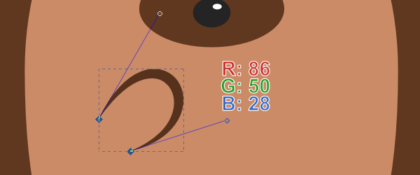

Step 4
Of course, duplicate and horizontal flip the hand for the other side. Again, you can position/space these as you please.
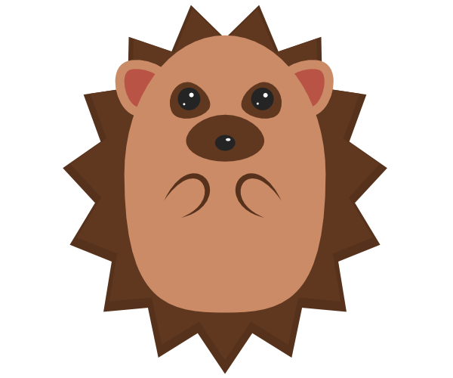

6. Draw the Feet

Step 1
We'll draw the feet the same as the hands (you can even just copy and paste for an added convenience). Go ahead and position it, but this is when you'll notice the "fill" issue with tapered lines. Let's solve this!
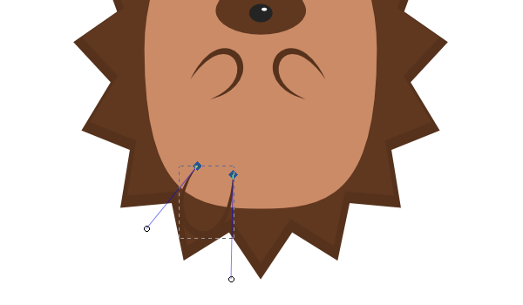

Step 2
Duplicate our foot and let's put it over a square (Object to Path that square). We're going to create a cut-out for the fill using some path operations. So with the foot and square selected, head up to Path > Intersection.
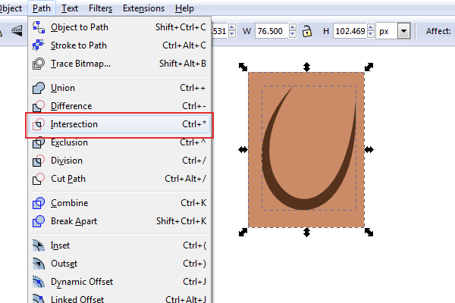
You should end up with something like this.
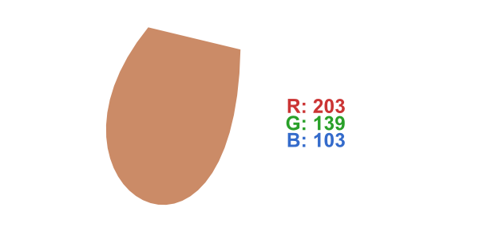

Step 3
You can now grab that foot fill and place it in the tapered line foot, preferably lower it behind the foot (Align and Distribute, center on both axis would also work to position the fill properly). When you've finished that, it's time to duplicate and flip.
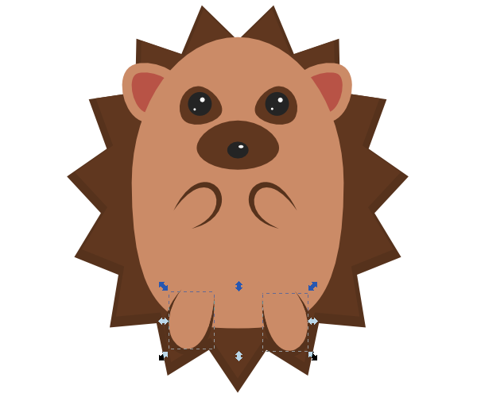

7. Add Shading

Step 1
To add a little more depth, let's duplicate the inner-body shape and give it that dark brown color.
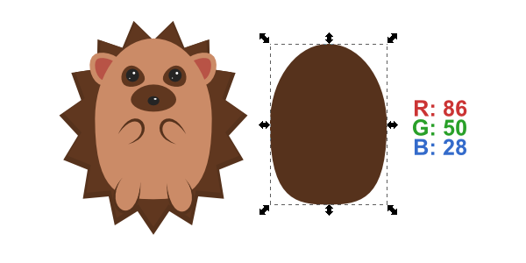

Step 2
We're going to place this shape under the main inner-body shape (using Lower or Page Down key). Let's offset it about 10px to the right and 10px to the bottom. You'll see that this makes the hedgehog's body pop out a bit.
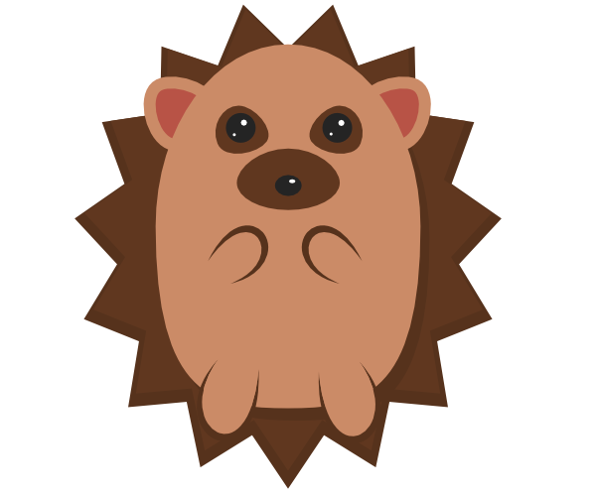

Step 3
For the hedgehog's whole shadow, duplicate the main spikes shape. We're going to make this shape black with an Alpha: 50.
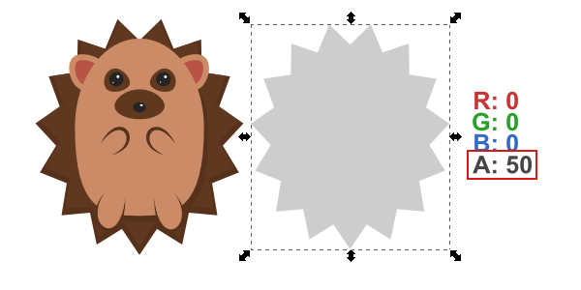

Step 4
Position accordingly (Lower to Bottom or End key). When you're done, you can select everything and groupthe hedgehog for easier access later.
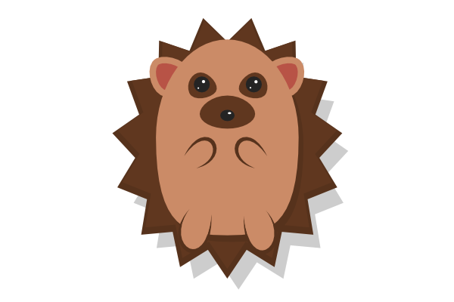

Step 5
Let's add that nice, green background now (I have a 600 x 600px canvas, so that's also my background size).
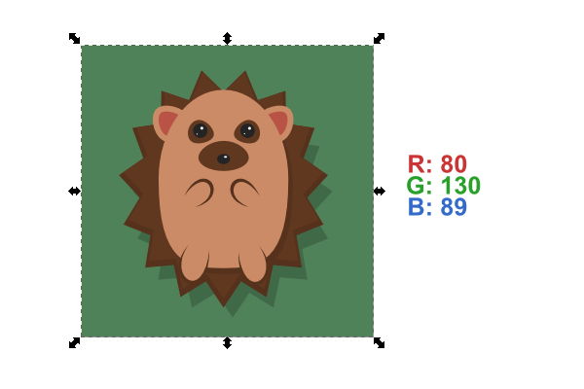

8. Draw the Leaves

Step 1
Use the Pen tool to draw a four-point triangle shape, and then smooth the bottom 3 nodes as shown below.
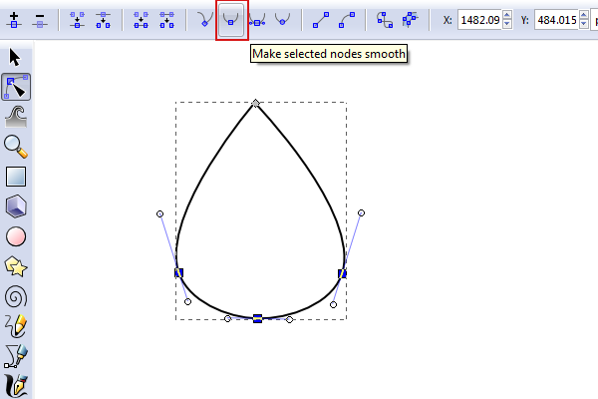

Step 2
Once you've got that leaf perfectly shaped, grab the Pencil tool and freehand a few of the details as shown below.
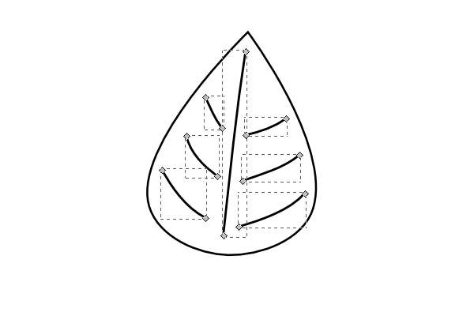

Step 3
Let's give this leaf an autumn color and then make those leaf lines black with the Alpha: 50 again.
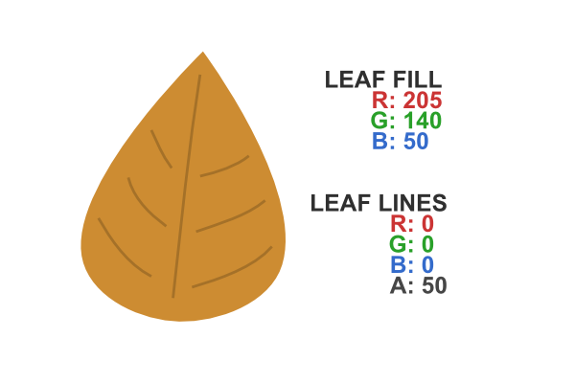

Step 4
Can't forget the stem! Just freehand it with the Pencil tool and give it a Width: 2 along with a rounded cap. Color the stroke with a dark gray. Also, you'll probably end up having to Lower it behind the leaf.
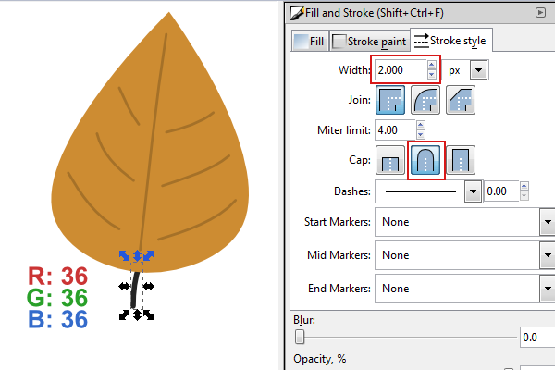

Step 5
To keep things awesome, let's duplicate the leaf a couple times to get some different color varieties. At this point, you'll want to Group each of these leaves (separately).
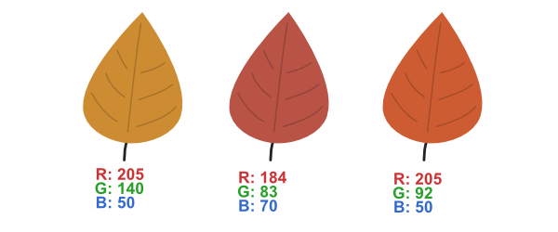

9. Scatter the Leaves

Step 1
Now that we've got our leaves all set, we need to spread them out. First, select your first leaf. Then immediately after, grab the Spray tool and set the options similar to what I have below (you can play with these options to your liking).
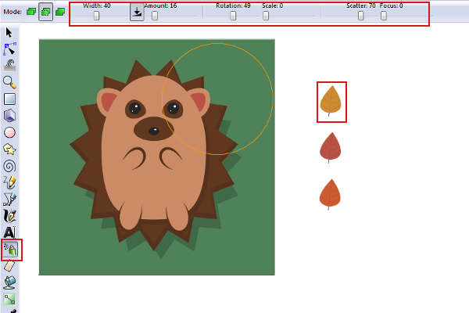

Step 2
Now you can just click-hold and spray the leaves around.
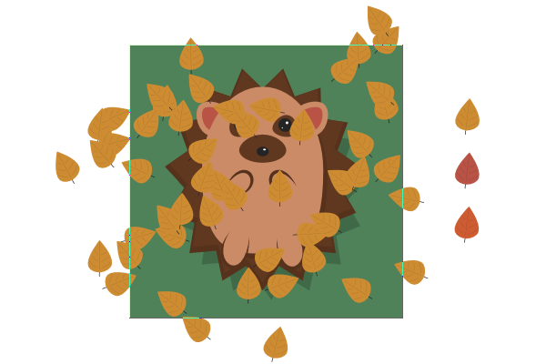

Step 3
Repeat with the other two colored leaves (remember, select the object in which to spray, then select theSpray tool to do so). When you're finished, select all of the leaves (shift-click to deselect anything) and Group all of the leaves.
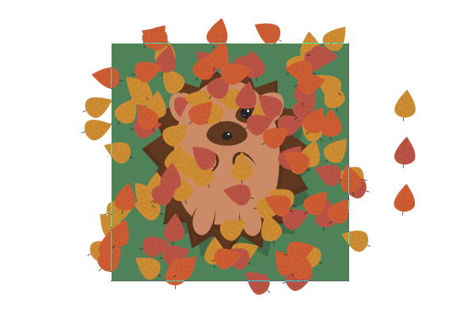

Step 4
With the leaves group selected, head up to Filters > Shadows and Glows > Drop Shadow to add some depth to this bunch of leaves. You can use similar settings shown below, or whatever looks best for you (don't forget to check Live preview... big help).
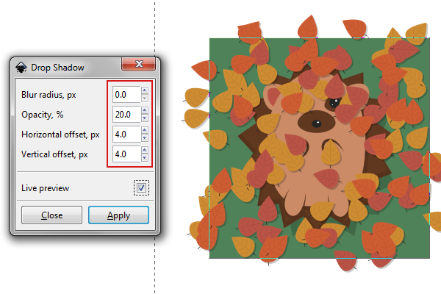

Step 5
With the shadow up to par, we can finally Lower this bunch of leaves behind the hedgehog. With everything in position now, I went back and picked out a couple of the leaves that I didn't particularly like. Of course, this process is completely random, so yours will be slightly different.
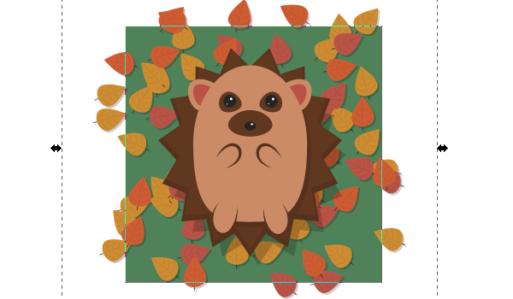

He's a Cute Little Guy, Great Work!
Here's our final product. Thanks for joining in on this Inkscape tutorial, I hope it was entertaining and full of some cool new things to do in your designs.

